Nama : Nabila marcha

Kelas : MI3A

NIM : 09010282327033

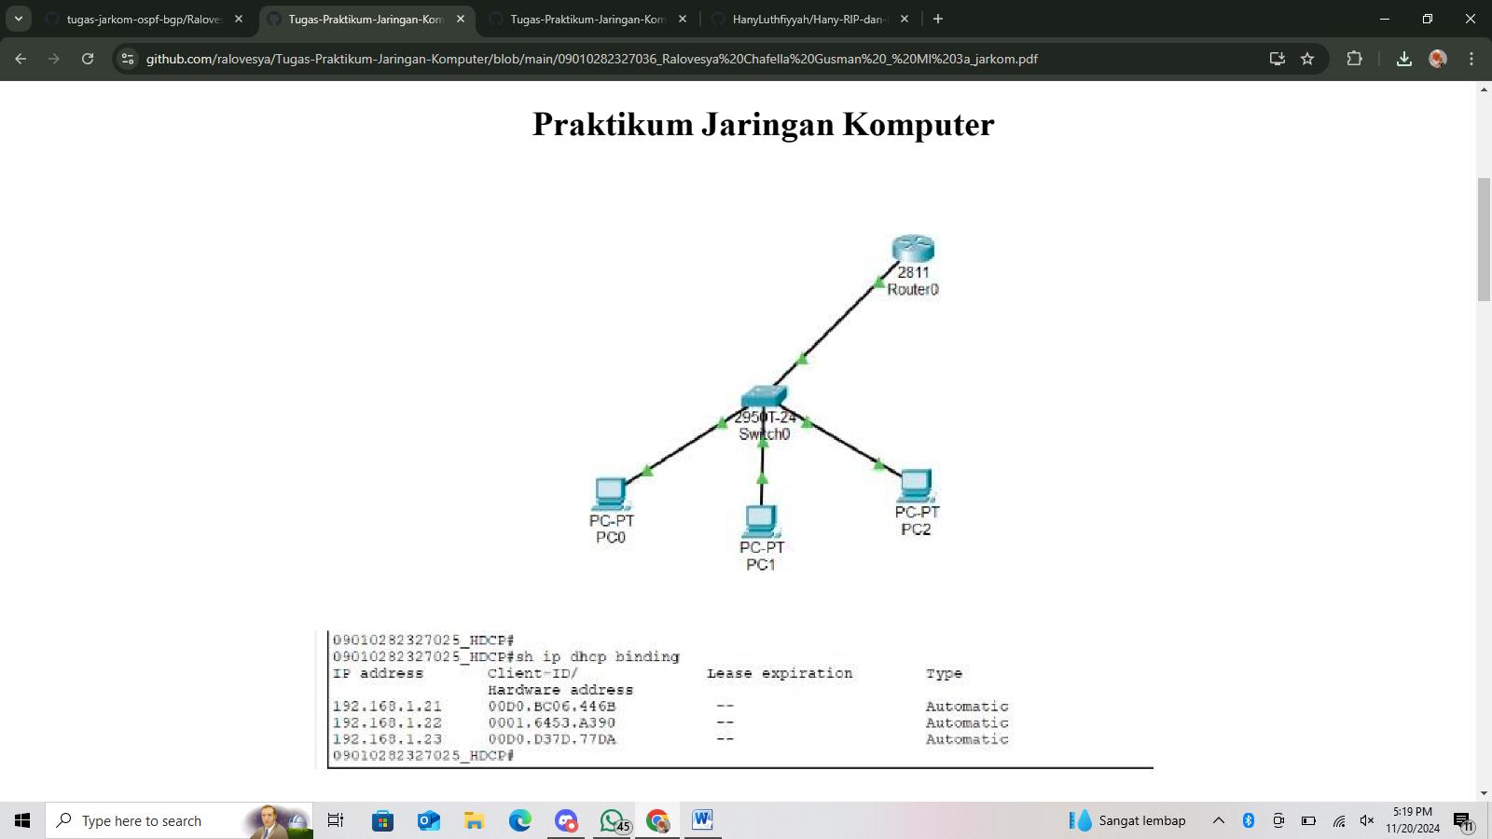Mk : prak jarkom

|  |  |  |  |  |
| --- | --- | --- | --- | --- |
| NO | IP ADDRESS | MAC ADDRESS | LEASE EXPIRATION | TYPE |
| 1 | 192.168.1.21 | 00D0.BC06.446B | - | AUTOMATIC |
| 2 | 192.168.1.22 | 0001.6453.A390 | - | AUTOMATIC |
| 3 | 192.168.1.23 | 00D0.D37D | - | AUTOMATIC |

|  |  |  |  |  |  |
| --- | --- | --- | --- | --- | --- |
| NO | CLIENT | IP ADDRESS | NETMASK | GATEWAY | DNS |
| 1 | PC 0 | 192.168.1.21 | 225.225.225.0 | 192.168.1.1 | 192.168.1.1 |
| 2 | PC 1 | 192.168.1.22 | 225.225.225.0 | 192.168.1.1 | 192.168.1.1 |
| 3 | PC 2 | 192.168.1.23 | 225.225.225.0 | 192.168.1.1 | 192.168.1.1 |

|  |  |  |  |  |
| --- | --- | --- | --- | --- |
| NO | SUMBER | HASIL | TUJUAN | HASIL |
|  |  | YA/TIDAK |  | YA/TIDAK |
| 1 | PC0 | YA | PC1 | YA |
|  |  | YA | PC2 | YA |
| 2 | PC1 | YA | PC0 | YA |
|  |  | YA | PC2 | YA |
| 3 | PC2 | YA | PC0 | YA |
|  |  | YA | PC1 | YA |

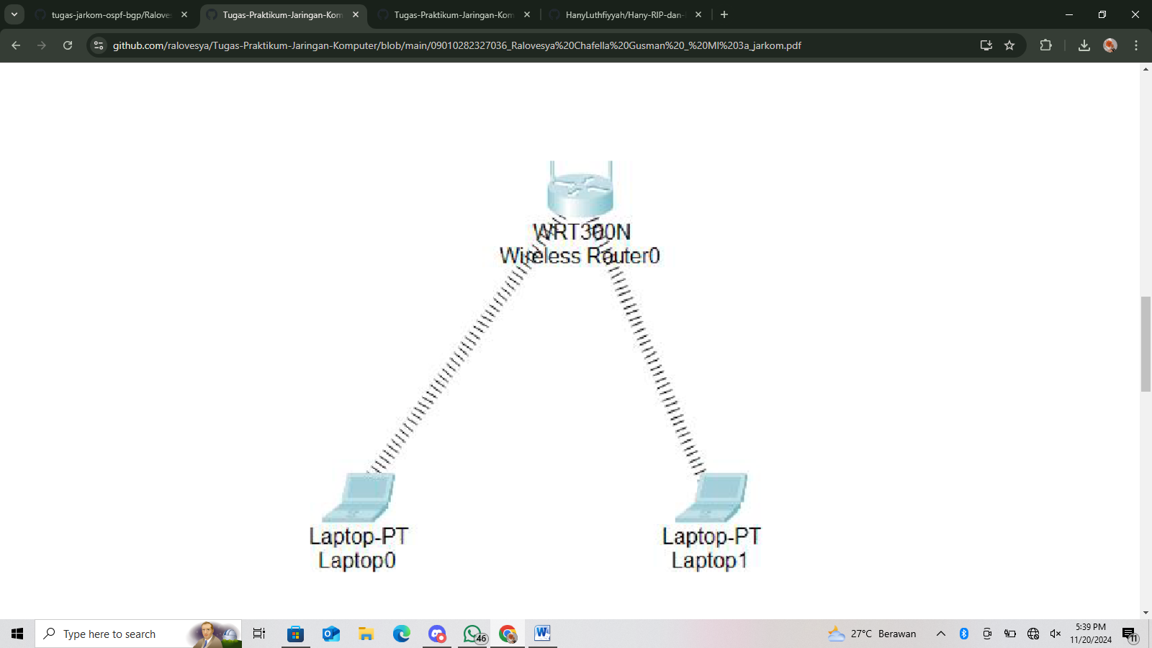

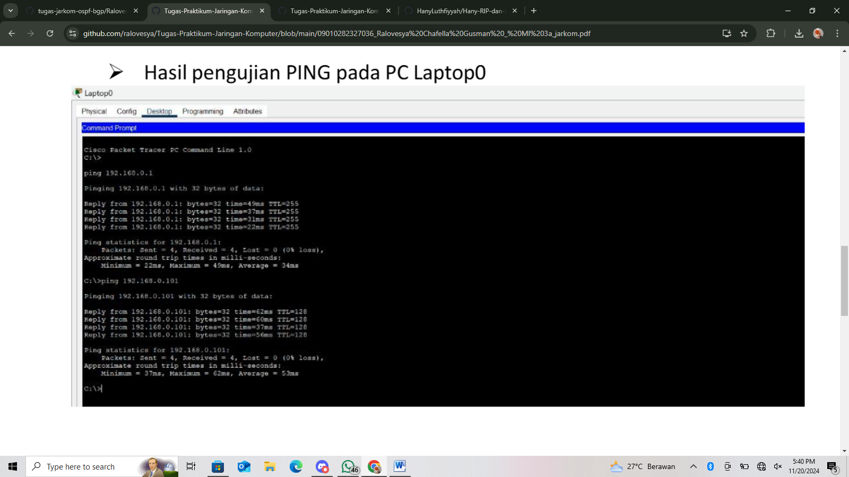HASIL PENGUJIAN PING PADA PC0

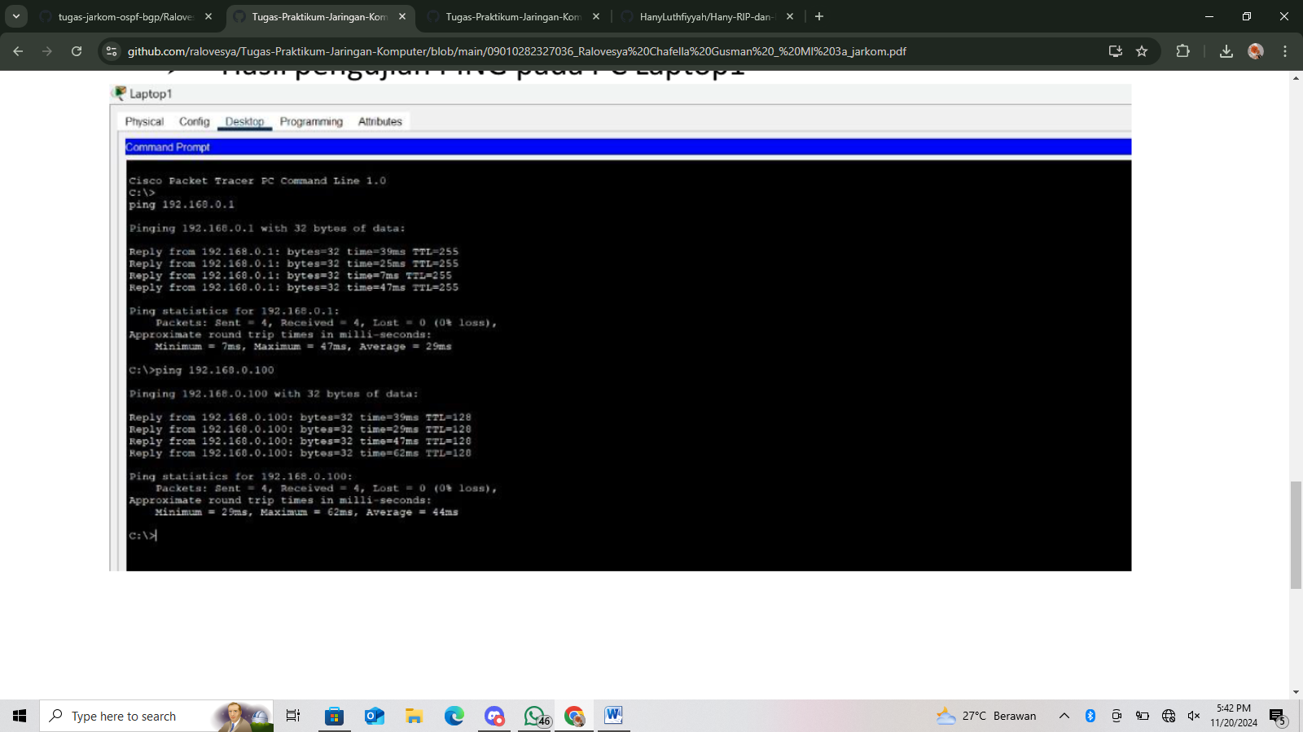HASILPENGUJIAN PING PADA PC1